**PHP header() Function**

The PHP **header()** function is used, when we need to send raw HTTP header. Most of the time, the **header()** function is used to redirect to another page/URL. For example:

<?php

if(isset($_SESSION['user']))

{

echo "Welcome to codescracker.com!";

// block of code, to process 'user'

}

else

{

header('Location: login.htm');

exit();

}

?>

In above example, since the session variable **user** is not set, therefore program flow goes to [else](https://codescracker.com/php/php-if-elseif-else-statement.htm) block and executes the **header()** function, that redirects to the **login.htm** page. Because I have already created a **login.htm** page in the current directory. Therefore the output of above PHP example is:

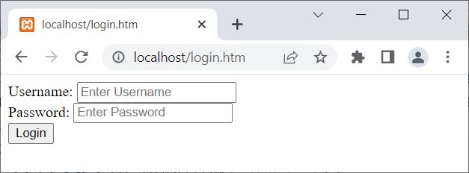

Since the page has redirected to **login.htm** in fraction of seconds, therefore we are directly seeing the **login.htm** page.

**PHP header() Syntax**

The syntax of **header()** function in PHP, is:

header(header, replace, responseCode);

From all three parameters, only the **header** parameter is required. And the other two parameters are optional.

**Note -**The **header** parameter is used to specify the header to send.

**Note -**The **replace** parameter is used when we need to specify whether the header should replace previous similar header or should add new header of same type.

**Note -**The **responseCode** parameter is used when we need to force the default HTTP response code to the particular one.

**Note -**The default value of **replace** parameter is **TRUE**. And the **TRUE** indicates that the header replaces the previous.

**Use PHP header() to Start Automatic Download of a File**

The PHP **header()** function can also be used to start an automatic download of a file on the client's browser. For example:

<?php

header('Content-Disposition: attachment; filename="myfile.pdf"');

?>

The output of above PHP example on **header()** function, to start an automatic download, is shown in the snapshot given below:

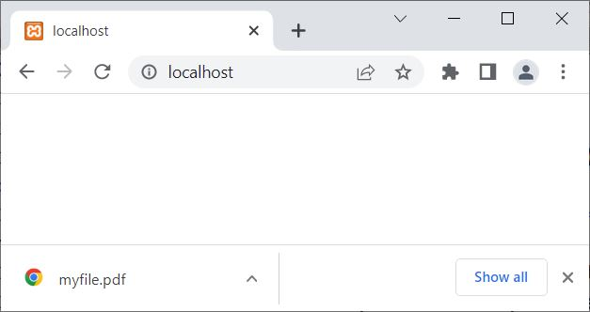

You can also use the **Content-Type** to indicate the original media type resource. That is, the **Content-Type** representation (in **header()**) is used, when we need to indicate the original media type of the resource (prior to any content encoding applied to send). For example:

header('Content-Type: application/pdf');

If you want to download a file with other name on the client's computer. For example, let us suppose, I have a file named **class_details.pdf** saved on my server. But i want to make this file, to download on the client's computer system with name **download.pdf**. Therefore, here is the code to follow, for this purpose:

<?php

header('Content-Type: application/pdf');

header('Content-Disposition: attachment; filename="download.pdf"');

readfile('class_details.pdf');

?>

Now a file named **download.pdf** will be downloaded on the client computer whose content will be same as the content of **class_details.pdf**, a file saved on my server. Most of the time, this is used by the developer, to avoid providing the same name of the file, saved on the server.

**Use PHP header() to Prevent Page Caching**

As we all knows that, PHP scripts known for its dynamic content. And the dynamic content must be not cached, either by the browser (client browser) or by proxy caches between server and browser (client browser). Therefore, we need to use some PHP code to prevent cache for some page/part of an application written in PHP:

<?php

header("Expires: Sat, 26 Jul 1997 05:00:00 GMT");

header("Cache-Control: no-cache");

?>

**Note -**Use PHP [getallheaders()](https://codescracker.com/php/php-getallheaders-function.htm) function to get all HTTP headers.